Program Structures and Algorithms

Spring 2024

NAME: Gautham Venkata Krishna Prasad

NUID: 002249901

GITHUB LINK: https://github.com/gauthamkris7neu/INFO6205Assignment

**Task:**

Assignment 5 (Parallel Sorting)

**Relationship Conclusion:**

From the data we got from the benchmark runs, it appears that the parallel sorting algorithm demonstrates improved performance with increasing thread count up to a certain point. The data indicates that using this sorting algorithm yields a decrease in sorting time with an increase in threads, conforming to a trend where T = K/t for t ≤ p (where T is time, t is the number of threads , K is a constant, and p is the number of processors). However, this benefit does not scale linearly, and once the number of threads exceeds the number of processors (t > p), the time reduction flattens out due to overhead, suggesting an optimal thread count close to the physical limit of the processor.

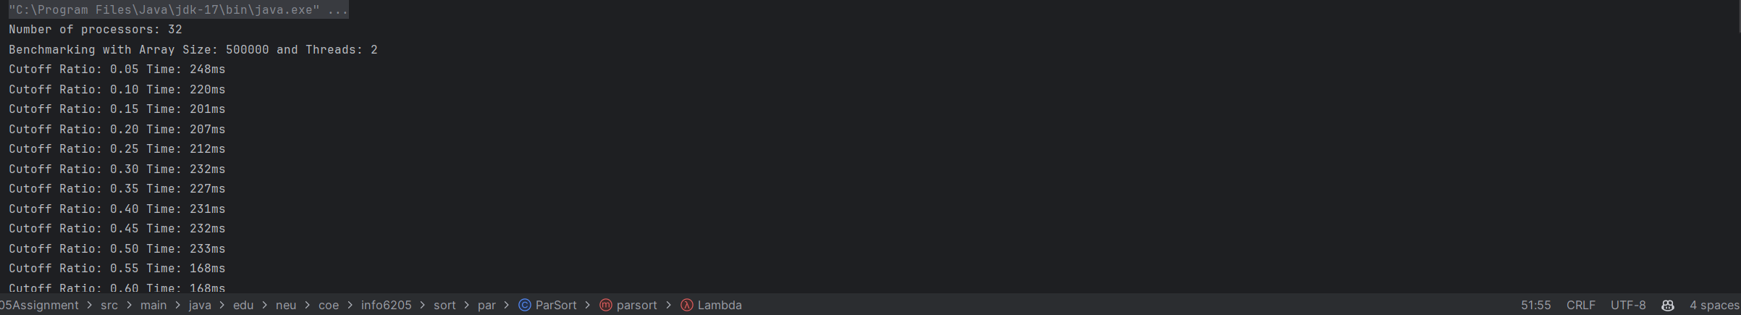

**Evidence to support that conclusion:**

|  |  |  |  |  |  |  |  |  |  |  |  |  |  |  |  |  |  |
| --- | --- | --- | --- | --- | --- | --- | --- | --- | --- | --- | --- | --- | --- | --- | --- | --- | --- |
|  | Array Size = 500000 | | | | | Array Size = 1000000 | | | | | | Array Size = 2000000 | | | | | |
| Cutoff Ratio | T2 (ms) | T4 (ms) | T8 (ms) | T16 (ms) | T32 (ms) | | T2 (ms) | T4 (ms) | T8 (ms) | T16 (ms) | T32 (ms) | | T2 (ms) | T4 (ms) | T8 (ms) | T16 (ms) | T32 (ms) |
| 0.05 | 230 | 143 | 154 | 147 | 111 | | 303 | 308 | 286 | 272 | 220 | | 659 | 626 | 590 | 613 | 445 |
| 0.1 | 215 | 170 | 176 | 127 | 104 | | 358 | 299 | 338 | 252 | 209 | | 706 | 660 | 753 | 538 | 404 |
| 0.15 | 234 | 172 | 152 | 106 | 109 | | 393 | 413 | 314 | 210 | 208 | | 773 | 835 | 647 | 417 | 420 |
| 0.2 | 249 | 190 | 153 | 106 | 104 | | 406 | 398 | 316 | 210 | 209 | | 788 | 857 | 650 | 413 | 423 |
| 0.25 | 197 | 185 | 150 | 104 | 105 | | 372 | 392 | 315 | 212 | 214 | | 866 | 826 | 643 | 411 | 414 |
| 0.3 | 227 | 173 | 122 | 121 | 122 | | 464 | 360 | 242 | 244 | 242 | | 952 | 734 | 497 | 501 | 499 |
| 0.35 | 224 | 177 | 120 | 120 | 124 | | 458 | 358 | 243 | 245 | 244 | | 966 | 740 | 497 | 499 | 498 |
| 0.4 | 220 | 176 | 121 | 121 | 122 | | 464 | 359 | 243 | 243 | 245 | | 952 | 718 | 497 | 502 | 498 |
| 0.45 | 231 | 173 | 119 | 121 | 118 | | 466 | 347 | 244 | 242 | 246 | | 960 | 725 | 495 | 502 | 494 |
| 0.5 | 229 | 174 | 123 | 121 | 122 | | 462 | 347 | 243 | 244 | 244 | | 963 | 728 | 495 | 495 | 495 |
| 0.55 | 161 | 158 | 158 | 160 | 159 | | 330 | 332 | 330 | 332 | 332 | | 676 | 690 | 680 | 677 | 677 |
| 0.6 | 164 | 161 | 161 | 159 | 161 | | 329 | 332 | 331 | 331 | 339 | | 685 | 683 | 683 | 682 | 690 |
| 0.65 | 159 | 163 | 162 | 160 | 161 | | 331 | 331 | 331 | 327 | 332 | | 682 | 688 | 685 | 676 | 684 |
| 0.7 | 156 | 160 | 162 | 163 | 163 | | 326 | 332 | 332 | 330 | 329 | | 685 | 686 | 688 | 682 | 685 |
| 0.75 | 158 | 161 | 159 | 159 | 159 | | 331 | 329 | 330 | 329 | 332 | | 680 | 685 | 686 | 679 | 683 |
| 0.8 | 157 | 162 | 165 | 162 | 160 | | 333 | 335 | 333 | 330 | 328 | | 680 | 686 | 679 | 683 | 680 |
| 0.85 | 158 | 159 | 159 | 158 | 157 | | 328 | 334 | 331 | 330 | 328 | | 680 | 687 | 684 | 685 | 686 |
| 0.9 | 160 | 161 | 161 | 159 | 163 | | 331 | 333 | 330 | 334 | 330 | | 681 | 682 | 686 | 687 | 683 |
| 0.95 | 159 | 161 | 160 | 160 | 159 | | 330 | 333 | 331 | 332 | 333 | | 680 | 687 | 682 | 681 | 685 |